**DAILY ONLINE ACTIVITIES SUMMARY**

|  |  |  |  |  |  |  |  |
| --- | --- | --- | --- | --- | --- | --- | --- |
| **Date:** | **20-05-2020** | | | | **Name:** | **Syed Hudaif Ibrahim** | |
| **Sem &**  **Sec** | **VI B** | | | | **USN:** | **4AL17CS104** | |
| **Online Test Summary** | | | | | | | |
| **Subject** | | **SSCD IA Test** | | | | | |
| **Max. Marks** | | **30 Score 19** | | | | | |
| **Certification Course Summary** | | | | | | | |
| **Course** | **Full Stack Web Developer** | | | | | | |
| **Certificate Provider** | | | **Udemy** | **Duration** | | | **4 Weeks** |
| **Coding Challenges** | | | | | | | |
| **Problem Statement:**  1.Python Program to Execute the Values of Two Number using ^ (exclusive or operator).    2.Write Python Program to Reverse a Given Number. This is a Python Program to reverse a given number. | | | | | | | |
| **Status:Completed** | | | | | | | |
| **Uploaded the report in Github** | | | | **Yes** | | | |
| **If yes Repository name** | | | | [https://github.com/SyedHudaif/Online-Codingupdates](https://github.com/SyedHudaif/Online-Coding-updates)  [https://github.com/SyedHudaif/Certificationcourse-updates](https://github.com/SyedHudaif/Certification-course-updates) | | | |
| **Uploaded the report in slack** | | | | **Yes** | | | |

**Online test Detail:**

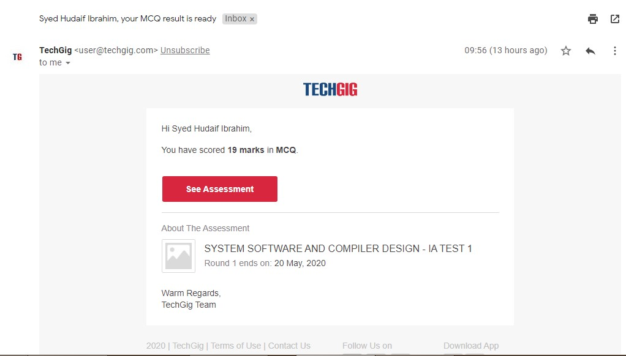

**Online Certification Details**

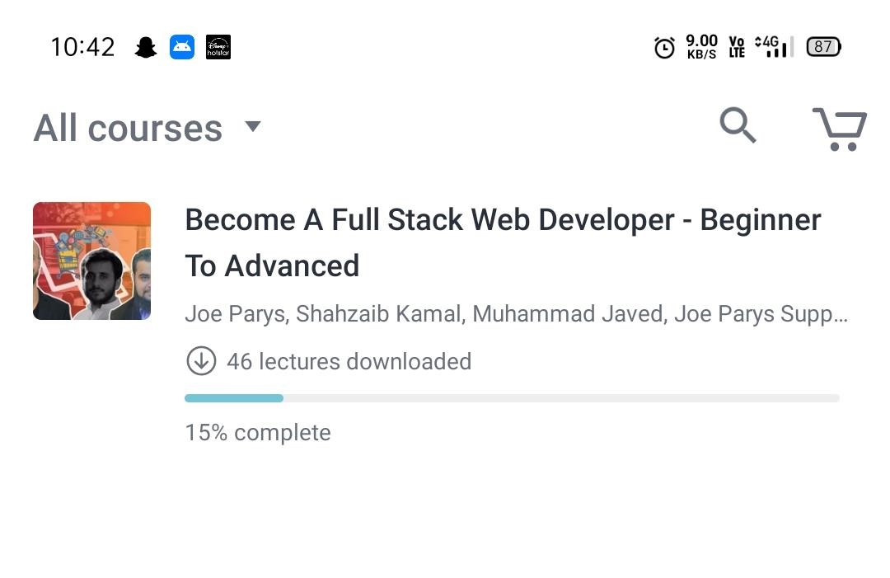

**Coding Challenge Details**

1.Python Program to Execute the Values of Two Number using ^ (exclusive or operator)

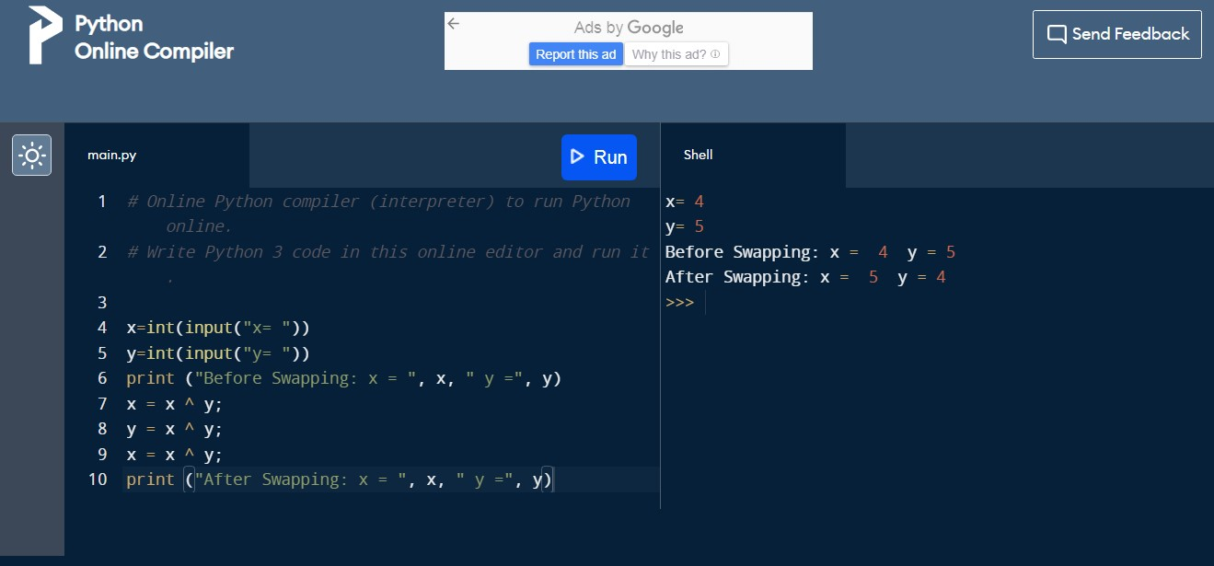

2. Write Python Program to Reverse a Given Number. This is a Python Program to reverse a given number.

